Using the NM Assistant app:

There are two basic uses of this app, the more common usage being the first:
- Basic Usage: Offline Maps:
Saving Maps
  - A map showing a track you wish to hike
  - A map showing only a region (no track) where you will hike
In either case, you can pull up the map for display - with or without internet – and a pulsing blue dot with show your location.
Using Offline Maps (discussed below)
- Creating track files (.gpx) while you hike. It can be shared, emailed or saved when you end the hike.

1. BASIC USAGE: Offline Maps
When you first open the app, it will show a large area map centered on Albuquerque. When you ‘Allow Location Services” the map will re-center on your current US location wherever you are. This location is saved, so that if you go to a place where there is no internet, it will default to this (last opened) location.


The Menu:
To use offline maps, you must first save one. Click on the ‘Menu’ icon to open the menu.

You will see the following menu [The menu can be closed by tapping anywhere outside the men]
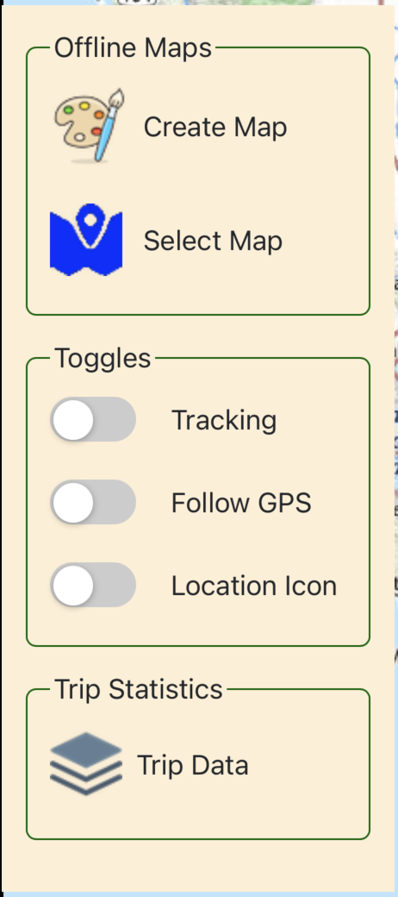
The first thing to do is to tap “Create Map”.
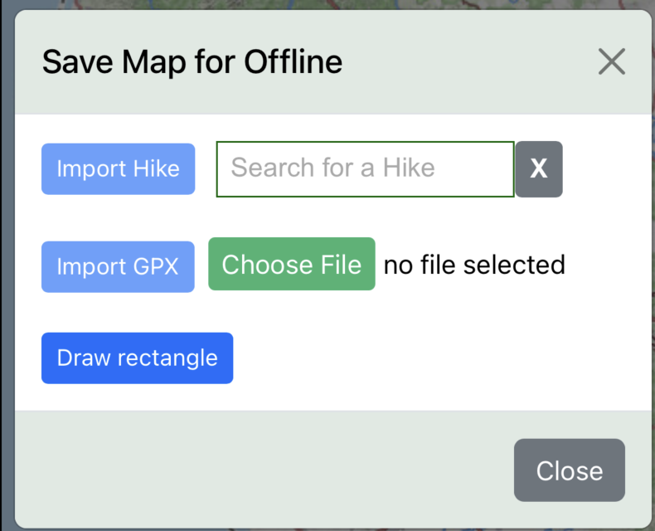
You will see the following:

This shows that there are three ways to proceed:
- Import a hike directly from nmhikes.com
- Import any .gpx file (from your phone’s file folder, or other app)
- Pan the map to an area you wish to save for later, and draw a rectangle to capture it.
Each of thes three methods is discussed:
- Site hike: simply begin typing the name of the nmhikes.com hike into the search box, then click on the hike. It will display in the search box, and the “Import Hike” button will now be enabled.
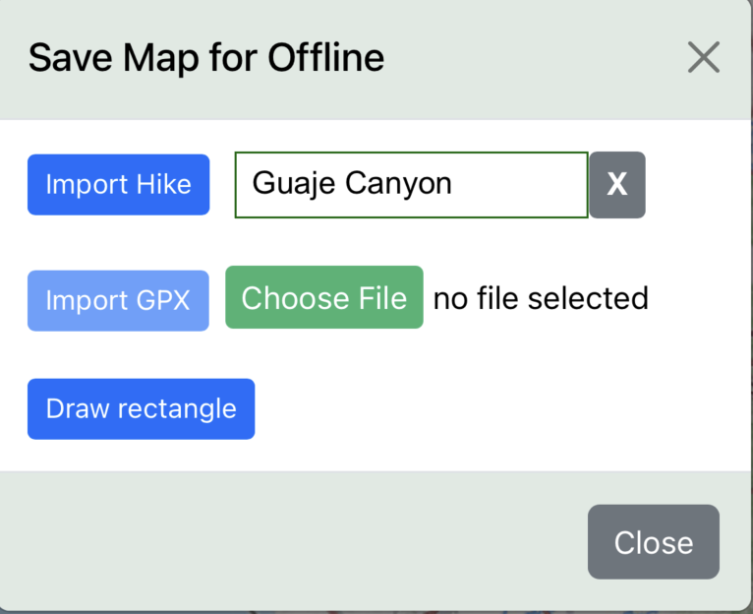
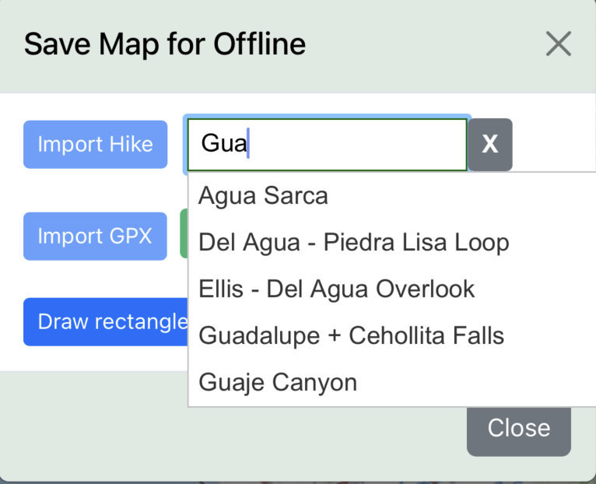

-- >

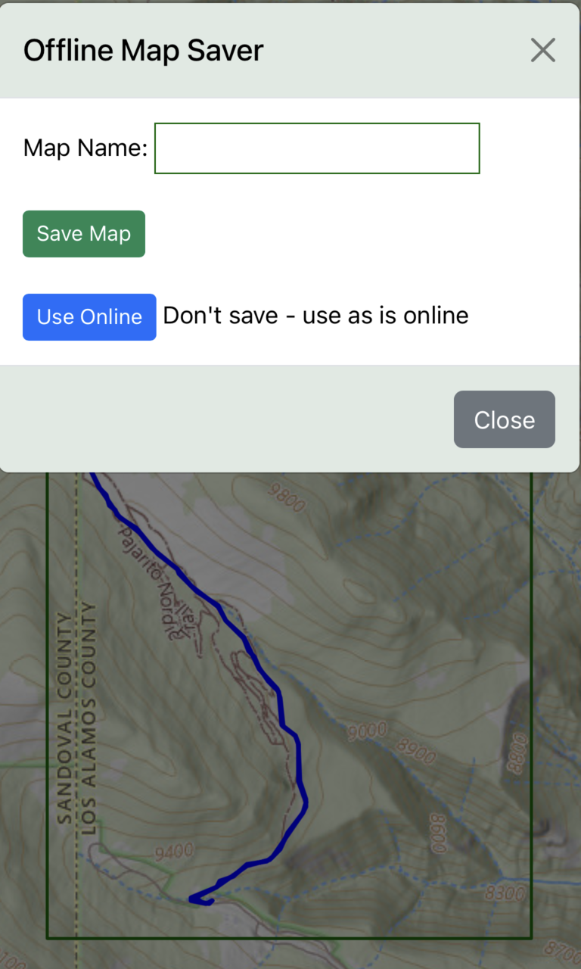
Click the ‘Import Hike’ button to display and save the map:

Enter a name for the map
Then tap ‘Save Map’. If you don’t want to save it and just want
to use it while connected to the internet, tap ‘Use Online’

If you are saving the map, you will see a Save Status
window showing the progress of saving
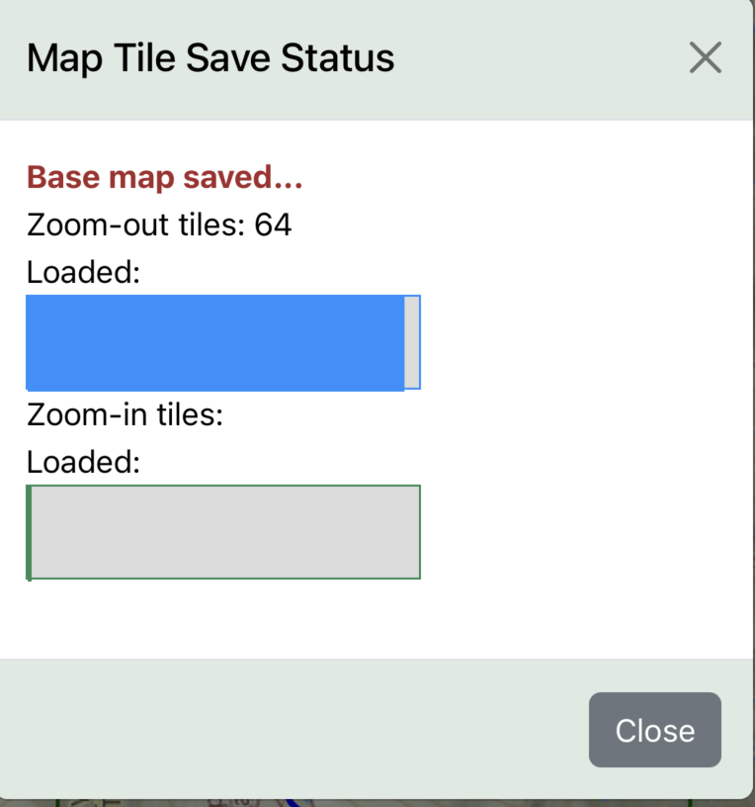

When the Save Status window shows “SAVED!”, you can close the window – the map has been saved.

- GPX File: the process is virtually the same as above, except you are going to import an existing “.gpx” file from your phone. When you tap “Choose File”, your phone will browse available locations, .e.g.
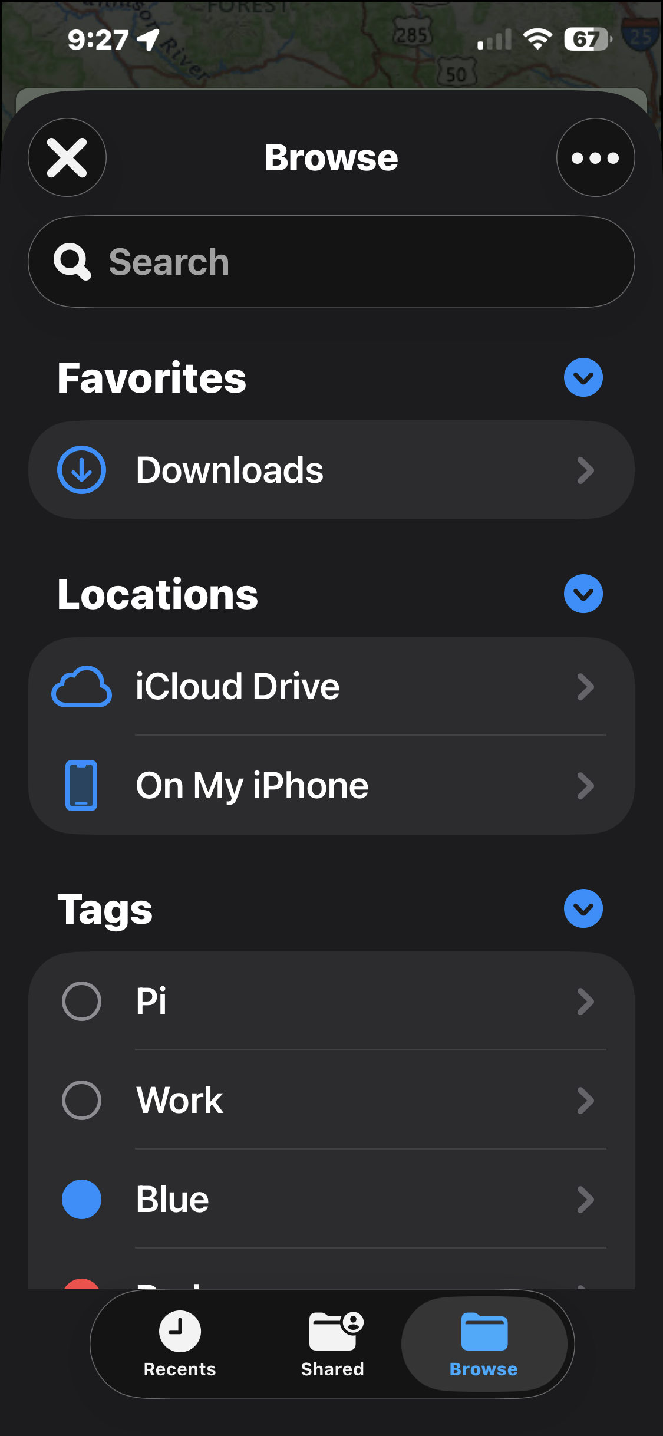
After selecting a file, simply tap the “Import GPX” button, and the
remaining process of saving is the same as previously described.

- Draw Rectangle: Use this when you are going somewhere and there is no gpx file or nmhikes.com hike to import. When you tap the ‘Draw Rectangle’, you will see the following:
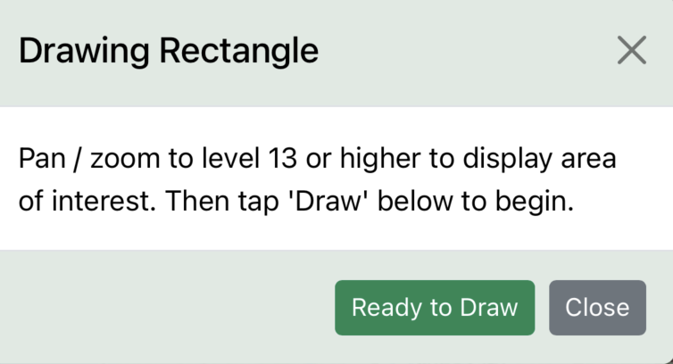

At this point, simply tap ‘Ready to Draw’, then pan anywere and zoom to the area you want to save. Note that the zoom level is always shown on the map in the upper left corner. In order to save the area, you must zoom in to zoom level 13 or higher – lower zoom levels consume too much memory. Here is an example of panning and zooming near Leadville, CO.
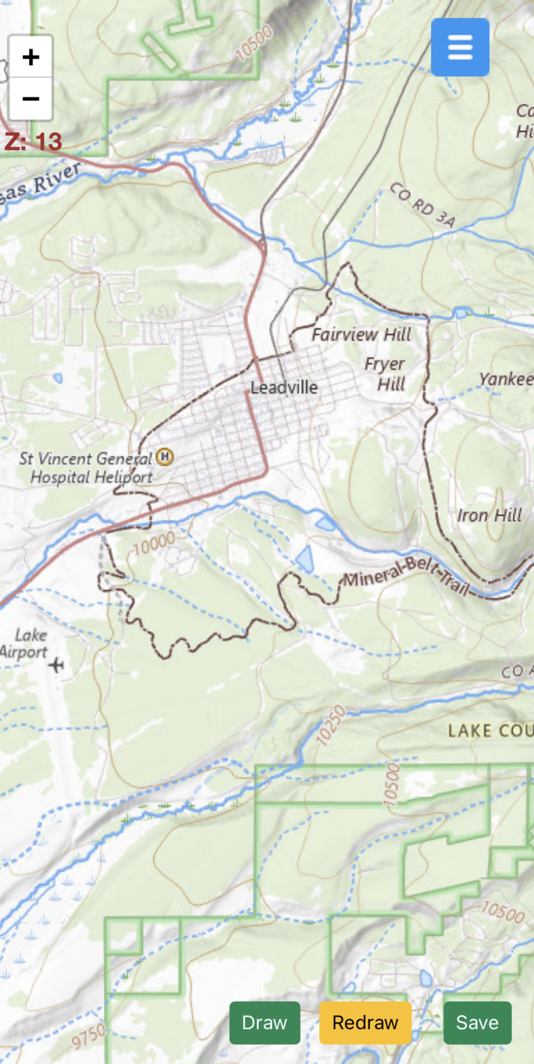

Note the buttons: Tap ‘Draw’ when you are ready
to draw a rectangle on the map with your finger.
When you are done, tap ‘Save’. If you don’t like
the area you chose, you can tap ‘Redraw’ and
then ‘Draw’ again, to get a new area.

Saving is as described previously.

NEXT you will want to use your offline map when you arrive at your destination. Internet is no longer needed! Tap the menu button, then tap “Select Map”. You are presented with a choice of the maps you saved:
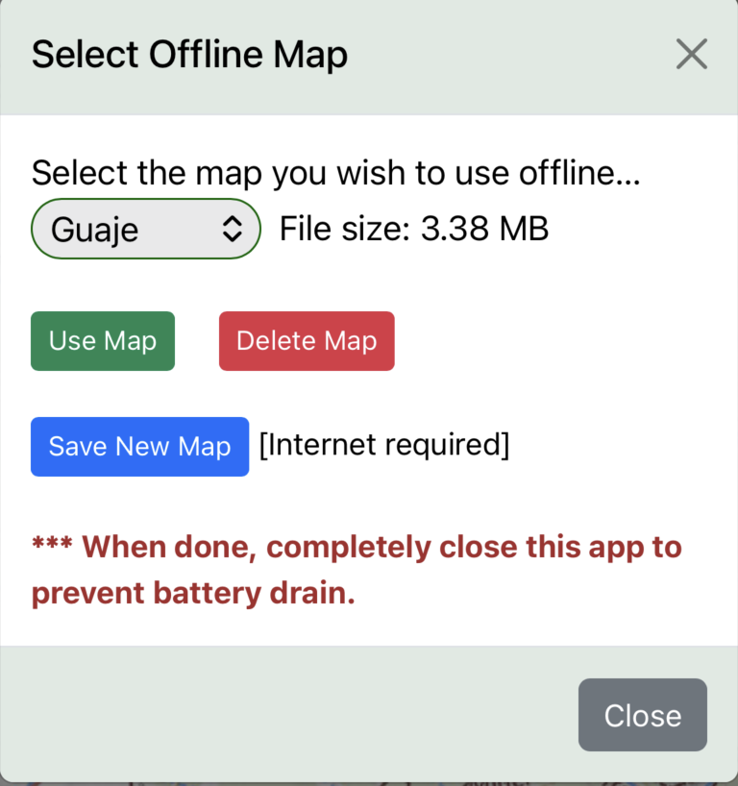

After selecting the map you wish to use in the drop-down box, you can
- Use the map displayed in the selection drop-down
- Delete the map from memory
- If you have internet, you can go back and save another map.
When you tap ‘Use Map’, the map and any track will be displayed, again internet not required.
A pulsing blue dot will indicate your location as you move around.
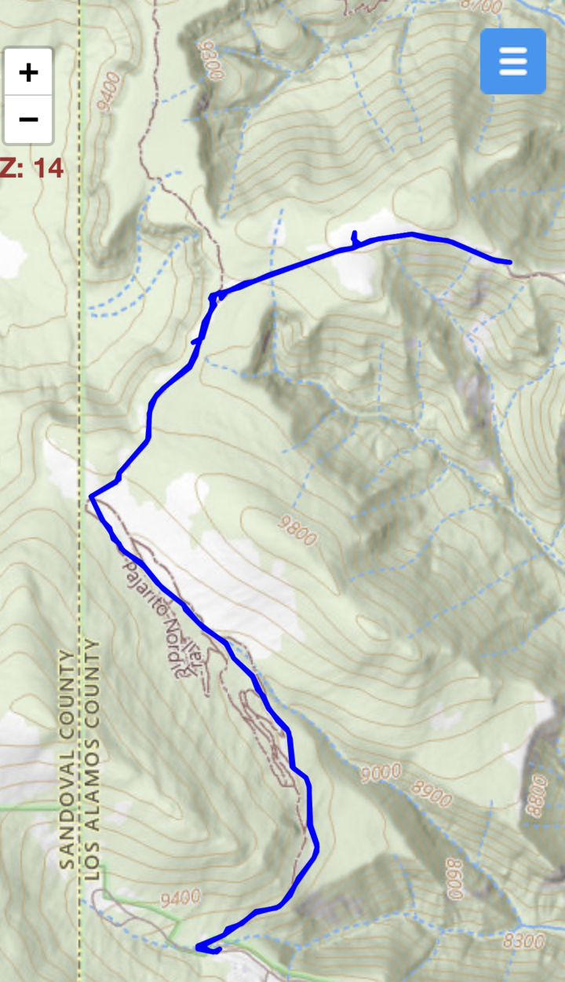

2. CREATING TRACK FILES: Online or Offline
The menu has several ‘slide’ toggles. To begin the tracking function, which records your movement whether or not the app is visibly open [called ‘background mode’], tap the slider for ‘Tracking’. It will slide to the right and turn blue, with the tracking icon shown on the map as a red icon with a white arrow. You may now close the menu, or simply tap the red icon to begin tracking – it will close the menu. Tapping the red ‘Start’ icon shows a set of options:
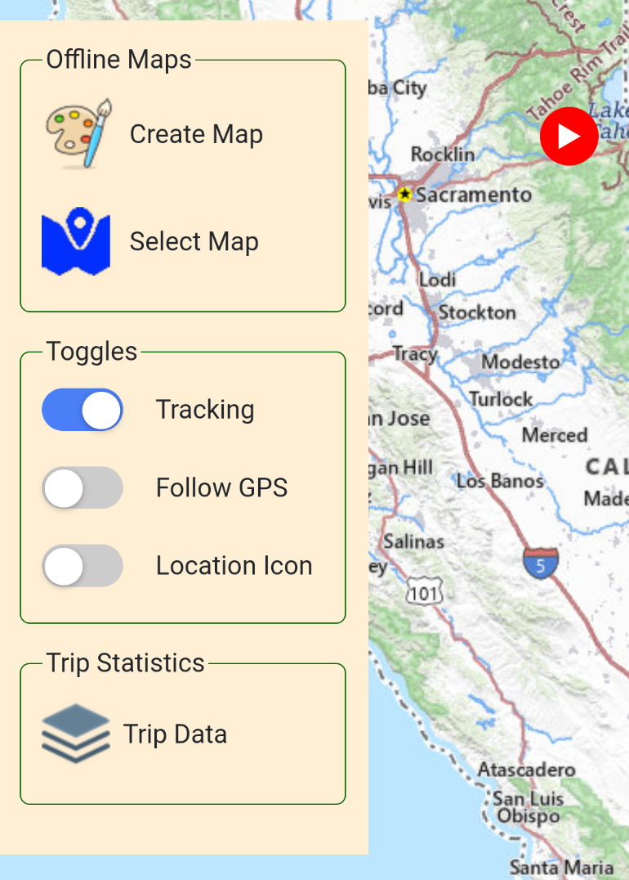
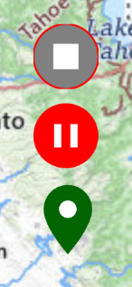
This icon wil stop tracking and offer to save the track file

This icon will pause tracking until it is turned back on

This icon will place a waypoint marker at your current location: it will ask for identifying text

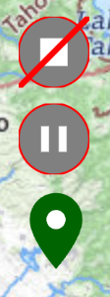
When the red ‘Pause’ button is tapped, tracking will not continue, and the new set of icons looks like this:

The red line through the ‘Stop’ icon simply indicates that tracking is inactive. You will not be able to stop and save until the pause is off (red pause icon).

At any time during or after tracking, you can view the Trip Data (see menu) which records your track statistics. This is what the ‘Trip Data’ window will look like, except with actual track data:
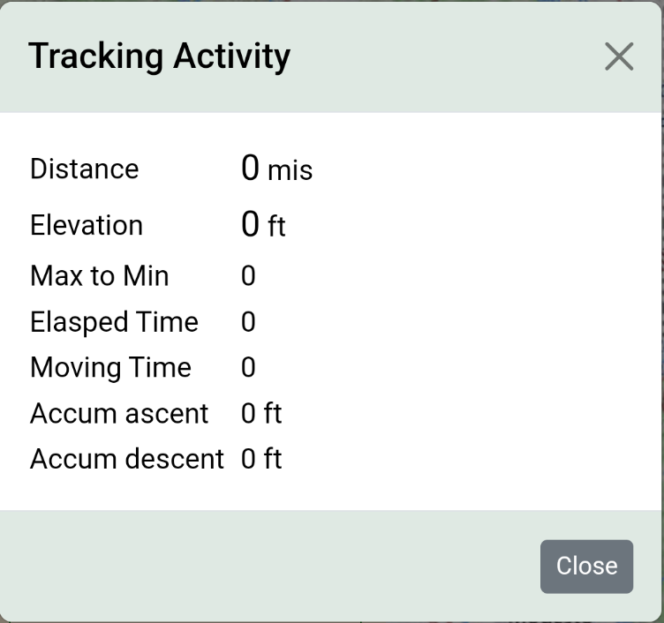

Another feature of this app is the dubiously named “Follows GPS” icon. This icon will be displayed when the menu slider “Follows GPS” is tapped:
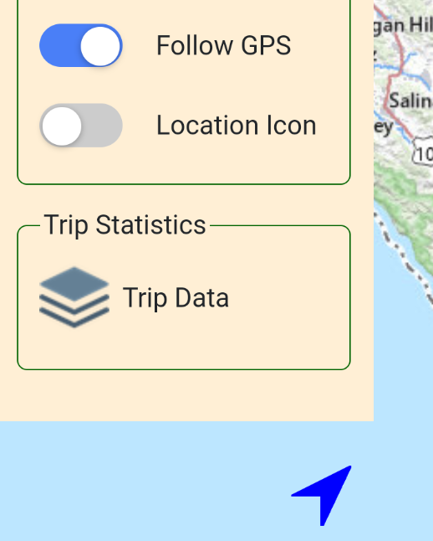

When the blue arrow is solid, the map will not recenter on your
location as you move. When you tap the icon, a ‘hollow’ arrow appears letting you know that the map will constantly recenter on your current location.


The final feature is a geolocation icon appearing at the top of the map next to the menu icon. In the menu, click the ‘Location icon” slider, and it will appear. When this icon is tapped, it simply recenters the map on your current location.
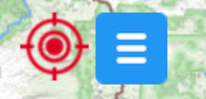

Notes:
- The app will track your movements even if the display is not open – that is, the app can be minimized or backgrounded by another app – tracking is taking place in the background. Only completely closing the app will kill the tracking function. However, the next time you open the app, it will offer you the opportunity to save the data present at the time of closing.
- When you stop tracking, a window pops up offering you options about saving the track file you have created:
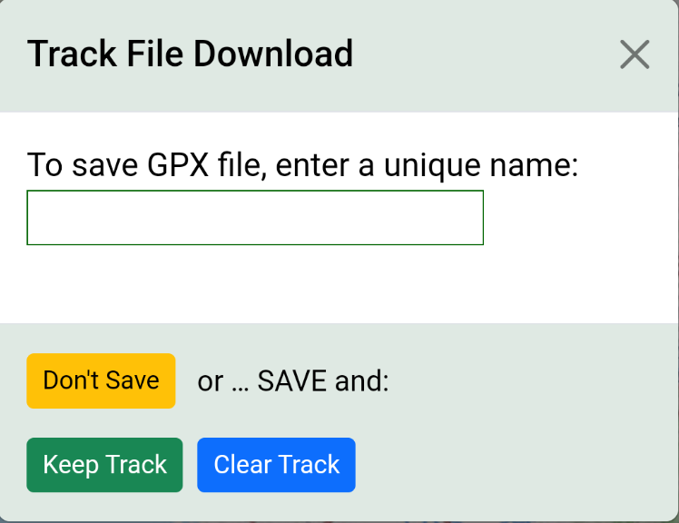

When you save the file (either w/’Keep Track’, or w/’Clear Track’), your phone will provide options about where to save: it may offer to share, download, email, etc. depending on the phone o/s.

